Victory Base Complex

Installation Access Control Badge System

And

Installation Access Control Standard Operating Procedure
Version 6.4, 1 June 2005.

A. Purpose

- The purpose of the new Installation Access Control Badge System is to reduce risk to the force from possible terrorist threats.
- The Victory Base Complex (VBC) Base Defense Operations Center (BDOC) is revising its installation access control SOP in order to implement the new Iraq wide MNF-I Installation Access Control Badge System (IACBS).
- The BDOC also continues to assess the threat to Victory Base Complex. This SOP provides guidance in light of that continuous assessment.
- MNF-I is implementing the IACBS in the International Zone and will soon do so across the theater. The new badges will be standard at all MNF-I installations. Some badges will grant access across the theater.

B. Scope

- This SOP shall apply to the entire VBC.
- This installation access control standard operating procedure (SOP) supersedes all previous SOPs covering installation access and badging.
- This policy establishes procedures for VBC in accordance with MNF-I and
MNC-I FRAGOs and policies listed in paragraph D. References.
- The commanders responsible for control of VBC entry control points will use this access policy in executing their mission.
5. This SOP does not govern access to some restricted areas on the VBC. The organizations that control those restricted areas (e.g. Embassy Annex, Al Faw Palace, etc.) may require additional forms of identification.

C. General.

- VBC is a limited access installation. Access to VBC will be limited to those with a compelling need to enter in order to complete missions in support of MNF-I and MNC-I
- The Task Force Dragon commander is responsible for force protection for the VBC, implementation of the new access control system, and management of local access and standard operating procedures for this system.
- The badging procedure accounts for each individual’s trustworthiness and his need for access in order to complete his mission.
- Badges are not symbols of entitlement or status.
- Only those in possession of recognized access badges or those escorted by a badge holder with escort authority are allowed on the VBC.
- All personnel must display a proper badge while on VBC, with the exception of uniformed coalition military personnel.

D. References:

- MNC-I FRAGO 310, Installation access control policy update 04-06.
- MNF-I FRAGO 193, Installation Entry Control Badge, 10 Aug 04
- MNF-I FRAGO 245, MOD 1 to MNF-I FRGO 193, 26 Aug 04.
- MNF-I FRAGO 193, MOD 2 Installation Entry Control Badge, 23 Sep 04.
- MNF-I FRAGO 366, Standardized Installation Entry Control badges, 17 Oct 04
- MNF-I FRAGO 609 Installation access control policy update, 14 Jan 05.
- MNF-I FRAGO 610 MNF-I Contract screening operations.
- Annex G MNF-I Access Control Policy
- U.S. government contract number W91QEK-04-C-7280.

E. Responsibilities

1. MNC-I:
- Is the staff proponent, and provides oversight for this SOP.
- Ensures the necessary support to establish badging capability.
- Ensures each Installation appoints a Site Contracting Officer Representative and Site Coordinating Officer.

- TF Dragon (Base Defense Command) is responsible for:
- Issuing VBC access badges to Local National (LN) and Third Country National (TCN) workers requiring routine access.
- Maintaining policies and procedures for base camp access.
- Implementing procedures to issue and maintain accountability of all VBC access badges.
- Coordinating with the badge enrollment and issue facilities to ensure badges are issued only for properly screened individuals.
- Ensuring the badge issuing facilities maintain a database of all issued badges.
- Ensuring that all required information is contained in any badging or exception to policy packet sent to the Approval Authority.
- Establishing procedures to retrieve access badges from individuals when they no longer require installation access or when official business relationships are terminated.
- Disseminating and enforcing compliance with this policy.

- 166th ASG (Garrison Command) is responsible for:
  - Providing any necessary logistical support for the physical plant of the badge production, enrollment, as well as logistical support required for contractors as per the contract between DynCorps and the Department of Defense.
  - Appointing a Site Contracting Officer Representative and Site Coordinator to provide local oversight and coordination.
  - Coordinating for armed military escorts of LNs and TCNs who require access to VBC and do not have project specific escorts provided by sponsoring units.
  - Ensuring that all LNs and TCNs who require a badge have followed the procedures outlined in this SOP.
  - Must submit a memorandum to the Requesting Authority requesting an adjustment to badge expiration dates when contract modifications result in a reduced time limit for contract completion. This will necessitate a re-badging of the individual to change badge expiration dates

- The Area Defense Operations Centers (ADOC) are responsible for:
  - Developing and implementing procedures to issue and maintain accountability of VBC badges issued at their entry control points.
  - Conducting workforce security sweeps daily to spot check badge enrollment, and escort violations. Detain all unauthorized LN/TCNs workers in violation of the escort rules and or this SOP.
  - Reporting findings of contractors who fail to properly supervise, or escort their LNs and TCNs.
  - Developing specific escort procedures to ensure control of their escorts.
    - One escort for every seven LNs.
    - One escort for every ten TCNs.
  - Holding daily formal guard mount for escorts, and ensuring that escorts understand that they are personally responsible for the security, accountability, and conduct of those under their control.
  - Ensuring that visitors and temporary workers remain under the control of their escorts at all times when on the installation.
  - Ensuring that escorts monitor their visitors’ or temporary workers’ actions and activities at all times.

5. Sponsors:
  - Are normally commercial contractors, but may also be MNF-I personnel or US Embassy personnel.
  - Identify individuals who require access to VBC on a regular basis, certifying that they pose no threat to the Installation and sponsoring them as applicants for the MNF-I Installation Access Control Badge.
  - Develop and implement procedures to maintain accountability of their sponsored applicants, sponsored badge holders, and their badges within the scope of this SOP.
  - Assist applicants throughout the application process and submit completed applications to their Requesting Authority for review.
  - Coordinate applicants’ enrollment, badge pick-up, and any further security screening.
  - Conduct workforce security sweeps daily to spot check for badge and escort violations by all employees and sub-contractors.
  - Detain all unauthorized LN/TCN workers who fail to follow the procedures as outlined in this SOP, who fail to follow the directions of escorts, or whose behavior is suspicious or potentially dangerous to themselves or VBC security.
  - Verify that their employees are submitting enrollment information that is trustworthy and validating all submitted employee information.
  - NOTICE: Non-compliance with this policy may result in the termination of exceptions that may have been granted, revocation of issued badges to that contractor’s/sponsor’s employees and termination of the Contractor/Sponsor from performing services or work on VBC.

6. Requesting Authorities:
  - Will be LTC O5 or GS12s. Approval Authorities may authorize Requesting Authorities with the following ranks MAJ, CW4, CSM or GS-11 who supervises, oversees, or advises the sponsor’s organization. They can not be contractors.
  - Must be designated in writing by an Approving Authority.
  - A signature memorandum must accompany the letter designating the Requesting Authority. The enrollment and issuing facilities will use this memorandum to authenticate the Requesting Authority’s signature on badge applications.
  - Requesting authorities are honest brokers who must ensure that sponsors and applicants comply with this SOP. The requesting authority’s signature on a badge application certifies that the application is complete and accurate, that it has been determined that this applicant genuinely requires access to the installation in order to complete official business on a regular basis, and the recommend level of access indicated is required.
1). The applicant has a legitimate mission requirement to access the Victory Base Complex, the applicant is eligible for the badge recommended, the appropriate expiration date is on the application, and that the requesting authority has personally checked the applicant’s identification, employment contract, LEP screening (if applicable), and all other relevant documents.
  - Requesting Authorities will submit application request forms to the badging NCOIC through the ASG Badging Office.

7. Approving Authorities:
  - COL-level commanders on VBC who are responsible for force protection and base defense. They include and are limited to the commander, TF Dragon, the DCO, Task Force Dragon, and the commander, 166th ASG. (Commander, TF Dragon may delegate this authority in writing to LTC force protection officers on VBC.)
  - Must be appointed by memorandum and said memorandum must include a verifying signature card. The enrollment facilities will use this memorandum to authenticate the Approving Authority’s signature on badge applications.
  - Are accountable for monitoring the badge enrollment and issuing processes in accordance with this SOP and all applicable FRAGOs and regulations.
  - Ensure that the procedures are in place to verify badge application information for personnel that require access to the VBC.
  - Ensure that procedures are in place so that applicants have provided accurate information.
  - Ensure that adequate screening/vetting procedures are used appropriately.
  - Ensure that individuals who are found to be security risks are terminated from installation access.
  - Ensure that those individuals identified as security risks are referred for further evaluation or interrogation.
  - Ensure that Requesting Authorities follow established procedures to retrieve MNF-I Identification badges for violations of this policy.
  - The signature of the Approving Authority certifies proper awarding of the badge in compliance with this SOP.
  - The Approving Authority will forward all approved applications to the badging NCOIC who will take them to the enrollment facility.
l. The Approving Authority has authority for badge issue concerning the following individuals:
      - Locally Employed Persons.
      - Coalition Military.
      - DOD Civilians.
      - Coalition Government Civilians assigned to the installation.
      - Host Nation Military, National Guard or Iraqi Police Personnel.
- In situations where positions are not clearly defined for issuing a particular badge color or Iraq-Wide Access, the approving authority will submit recommendations through MNF-I DCS Strategic Operations Protection for staffing, and consideration.

8. Contracting Offices, Contracting Officers, and Site Contracting Officer Representative.
- Joint Contracting Command-Iraq, PARC Forces
(1) Ensure MNC-I policies are in compliance with applicable MNF-I contracting policies regarding the vetting and screening of personnel that require access to VBC.
(2) Take vetting and screening requirements developed by the designated agency and writes a local clause for inclusion in all new local contracts.
(3) Ensure the badging contractor, through the Contracting Officer’s Representative performs their duties in accordance with the contract.
(4) Write a local clause requiring contractors to turn in all badges issued under the contract prior to request for final payment to the COR. Clause must also require the contractor to return badges in the event of termination or when an employee no longer requires access to VBC, regardless of the badges’ expiration date.

b. Installation Contracting Offices
(1) Incorporate all PARC developed clauses into all future contracts.
(2) Distribute copies of all contract awards and modifications requiring badging of contractors to the appropriate Requesting Authorities for determination of appropriate badging requirements.

c. Site Contracting Officer Representative
(1) Is responsible for maintaining the list of designated sponsors and requesting authorities.
(2) Ensures that any contract modifications resulting in a reduced time limit for contract completion that will necessitate re-badging or any change to badge expiration dates is forwarded to the Requesting Authority so adjustments can be made accordingly.

      - Tenant unit commanders, staffs, agencies, and organizations are responsible for ensuring dissemination and compliance with this policy and providing armed military escorts for Red Badge and Temp Badge individuals that are working at or visiting their units.

10. Personal Responsibilities of Each Badge Holder, (All personnel desiring access to VBC will do the following):
- Carry on their person in plain view above the waist their MNF-I access badge at all times for identification upon entering or exiting VBC and facilities located on the installation. US Military personnel will present their Common Access Card. NOTICE: Individuals not wearing a military uniform (DCUs) must display their badge prominently at all times. The BADGE MUST BE IN PLAIN VIEW ABOVE THE WAIST!
- Submit to searches of their person, property, or vehicle whenever directed to by the local commander’s security forces or procedures. NOTICE: Refusal to present proper identification or submit to searches when entering or leaving an installation will result in access being denied.
- Provide biometric data (iris scan, finger prints, and facial photograph) when requesting the issue of a MNF-I access badge, or to gain entry through an ECP or at any other location on VBC, if required by the installation commander.
- Surrender their MNF-I access badge when it is necessary to replace it, when it has expired, when they depart the Iraqi Theater of Operations, when they no longer require access, when their employment is terminated, or when they are no longer officially sponsored.
- Report a missing or lost badge immediately by completing a lost and stolen badge form and submitting it to their sponsor. Sponsors will immediately notify the Requesting Authority for that badge holders and the BDOC. Failure to do so within 48 hours is grounds for denying a replacement badge. (see attachment E).
- NOTICE: Any alterations to the badge, including holes punched, will automatically invalidate the badge and it will be confiscated on the spot. Altered badges will not be accepted for entrance onto the installation.
- NOTICE: Violations of this policy may be grounds for denying access to the Victory Base Camp Complex, its facilities, and may lead to confiscation of your MNF-I Installation Access Control Badge.

F. Badges General

There are seven types of MNF-I badges authorizing unescorted access to MNF-I controlled installations. These badges are distinguished by a colored stripe determined by the category of the individual authorized access. The badge will also identify the bearer’s level of installation access as either Iraq-wide or restricted to a specific installation. A limited number of high-ranking Iraqi officials have their title shown on the colored stripe (for example, National Assembly Member). Only limited personnel may receive Iraq-wide access. The badge also includes a photo, expiration date, issuing installation, nationality, biographical information, access controls for the issuing installation, and security features. An additional temporary badge will be used for visitors. Sample badges and features are at attachment I. No changes will be made to the badge design. Badge colors will be issued in accordance with guidance contained herein. Exceptions may be granted after staffing and approval to the exception authority.

G. Badges Normally Issued to Third Country Nationals and Local Nationals:

- Types of access badges issued to Third Country Nationals (TCNs) and Local Nationals (LNs).
  - Yellow Stripe Badge. This Badge may be issued to vetted / screened LN or TCN contractor site managers and corporate executives who require escort privileges to escort employees for short-duration projects. Yellow stripe badges are also issued to selected mid-level Iraqi government officials who require access on a recurring basis, such as deputy governors; deputy mayors; regional, provincial, and city level council members, and other equivalent level officials, commissioned officers between the grades of 01-06 (and civilian equivalents) of the Iraqi military, national guard, and police; PSD leaders; UN Local National/TCN staff leaders; coalition and non-coalition NGOs who are not registered with USAID. non-coalition foreign embassy nationals (minister-counselor, counselor, first secretary, second secretary, third secretary, attaché’, military attaché’, assistant military attaché’); A limited number of local national or TCN site managers and corporate executives who require escort privileges to escort employees for short-duration projects; A limited number of non-coalition contractor leaders may also be approved for yellow badges. Access to particular Victory Base Complex facilities will be printed on the badge by letter code. D = DFAC, B = Billeting, P = Post Exchange, G = Gymnasium, M = MWR, H = Health Care. (See attachment H).
(1) Media Personnel who work and live in the International Zone, (may be issued Yellow badges).
(a). All Media Personnel on VBC will be escorted by PAO or other coalition military escort regardless of their badge color.
(b). They must also have a Press ID issue by the Combined Press Information Center (CPIC) which is located at the Convention Center in the International Zone.
(2) The bearer of this badge may or may not be granted access with the following security measures and privileges:
(a) Lane Access: Priority.
(b) Person Search: Yes.
(c) Vehicle Search: Yes.
(d) Weapons Card Required: Yes (Unless in uniform).
(e) Escort Privilege: Yes.
(3) The bearer of this badge will have access to VBC through ECP2, 4, and 13.

  - Orange Stripe Badge (Future Installation Access Badge-Currently the Local Green No-Escort Required Badge). This badge may be issued to the following types of people if routine access is deemed necessary and the individuals have gone through some type of approved vetting process. Access to particular Victory Base Complex facilities will be printed on the badge by letter code. D = DFAC, B = Billeting, P = Post Exchange, G = Gymnasium, M = MWR, H = Health Care. (See attachment H).
    - Iraqi lower-level government officials and employees (such as ministerial general managers and staff, and other equivalent level officials or Iraqi government employees).
    - Enlisted personnel in the grades of E1-E9 (and civilian equivalents) of the Iraqi military, NG, and police.
    - UN Local National and TCN staff members.
    - Non-Coalition contractor / subcontractor leaders / employees.
    - INIS ( Iraqi National Intelligence Service)
    - PSD members
    - Locally hired TCN Subcontractor Leaders
    - Iraqi Subcontractor Leaders
    - NOTES: Currently Local Green / New Orange Badges are issued to individuals whom requesting officers determine should have unescorted access. Normally they will have passed a CACI background check.
      - These badge holders do not require an escort on base.
      - These badge holders do not have unescorted access to secure areas (Palace, Embassy Annex, etc).
      - These badge holders may live on the base camp.
      - These badge holders cannot act as escorts for other workers.
      - Access may be authorized to the PX and DFAC.
      - Access is not authorized to the Gym or MWR.
      - These badge holders should have a memorandum stating if they are authorized entry into the facility to which they are trying to gain access.
    - EXCEPTIONS: A Local Green Badge holder will be able to go into the location at which he or she is employed.
a. Look for the access information in the employment section of the badge. E.g..If the badge states that he or she is an AAFES employee, than he or she will have access to the PX without a memorandum stating so.
    - Currently Local Green Badge holders have access to the base complex through ECP2, 4.
    - Orange stripe badges will have access to VBC through ECP2, 4, and 13.
    - The Local Green / New Orange Badge are not authorized to leave the Victory Base Complex. It must be turned in on any day the holder leaves the base.
    - Local Green / New Orange Badges are controlled items. They will be signed for, and strict accountability will be maintained at all levels.
    - Local Green / New Orange Badges shall be reconciled daily for those holders who leave the base each day to ensure that all badge holders who entered VBC, have left VBC, turning in their badges.
    - Orange Badge bearers may or may not be granted ECP access with the following security measures and privileges:
      - Lane Access: Priority.
      - Person Search: Yes.
      - Vehicle Search: Yes.
      - Weapons Card Required: Yes (Unless in uniform).
      - Escort Privilege: No.

  - Red Stripe Badge (Future Installation Access Badge-Currently the Local Red Escort Required Badge). Access to particular Victory Base Complex facilities will be printed on the badge by letter code. D = DFAC, B = Billeting, P = Post Exchange, G = Gymnasium, M = MWR, H = Health Care. (See attachment H)
    - These individuals are Sub-contractors or employees who are primarily LNs and TCNs who have been through an approved vetting process.
    - Types of these individuals are listed below:
      - Non-coalition contracted and subcontracted laborers
      - Locally hired TCN subcontracted laborers
      - Iraqi National Laborers
      - Iraqi Nationals who are employed within the International Zone.
    - These individuals require an armed military escort at all times.
    - They cannot be escorts.
    - Access is not authorized to the GYM, MWR, PX, or DFAC unless otherwise noted on the badge.
    - Currently, Red Badges are issued to individuals who have passed a limited background check and who routinely work on the base complex.
    - Red stripe badges will have access to VBC through ECP2, 4, and 13.
    - NOTICE: The Red Badges are not authorized to leave the Victory Base Complex. They must be turned in each day to the issuing Entry Control Point.
    - All Red Badges are controlled items. They will be signed for, and strict accountability will be maintained at all levels.
    - Media Personnel may be issued a Red Badge if they are embedded with coalition forces on VBC.
        - All Media Personnel on VBC will be escorted by PAO or other coalition military escort regardless of their badge color.
        - They must also have a Press ID issue by the Combined Press Information Center (CPIC) which is located at the Convention Center in the International Zone.
    - All Red Badges shall be reconciled daily to ensure that all badge holders have left the base and have turned in their badge to the badge issuing ECP.
    - The bearer of this badge may or may not be granted ECP access with the following security measures and privileges:
      - Lane Access: Regular.
      - Person Search: Yes.
      - Vehicle Search: Yes.
      - Weapons Card Required: Yes.
      - Escort Privilege: No.

  - Black Temporary Badges (Future Installation Access Badge-Currently the Temporary, Blue Diagonal and Yellow Candy Striped Badge).
    - Black Badges will be issued at Entry Control Points (ECP) for Visitors / Temporary Workers and those individuals who do not require regular access to the base complex.
    - This badge holder will be escorted by armed military escorts at all times. The badge must be visibly displayed on an individual at all times when on the installation. IN PLAIN VIEW above the waist!
    - The individual will surrender an official government-issued photo ID in exchange for a Black Badge.
    - The Black Badge shall be returned to the ECP upon departure from VBC at the end of the day.
    - The ECP shall establish procedures for signing Visitors / Temporary workers in and out of the installation.
    - The Black Badge will not be accepted for entrance onto any installation.
    - The installation commander will determine limits on the hours of access, but it will be for less than 24 hours.
    - The BDOC will issue Black Badges in bulk to the designated officer operating each ECP for escorting Visitors and Temporary Workers.
    - All Black Badges are controlled items. They will be signed for, and strict accountability will be maintained at all levels.
    - All Black Badges shall be reconciled daily to ensure that all Visitors / Temporary Workers have left the base and have returned their badge.
    - NOTE: Currently this badge is issued to LNs and TCNs who perform day to day temporary work, for fourteen days total, consecutive or non-consecutive.
    - The badge states “Temp Worker” on it. The New Black Badge will have a large letter “T” on it.
    - The badge holder requires an armed military escort at all times while on the base camp.
    - Black badges will be available at for issue at ECP2, 4, and 13.
    - Access to PX, MWR, GYM, and DFAC are not authorized.
    - The bearer of this badge may or may not be granted ECP access with the following security measures and privileges:
      - Lane Access: Regular.
      - Person Search: Yes.
      - Vehicle Search: Yes.
      - Weapons Card Required: Yes.
      - Escort Privilege: No.

H. Exceptions and Guidance for Exceptions

1. Exception to Policy must understand that exceptions to this SOP are limited.
2. There are three levels of Exception Authority, Installation Approval Authority, MNF-I Chief of Staff and MNF-I Director of Force Protection.
3. Exceptions may be granted on a case by case basis, after considering all the facts and circumstances.
4. The Exception Authority will not grant exceptions for Iraq-Wide Badges.
5. If any exception is granted the approval memorandum will be maintained on file.
6. For exceptions for Blue, Green and Brown Badges the Approving Authority will submit recommended exceptions to the MNC-I Chief of Staff.
7. Exception Authority for Iraq-Wide access is the Director, Protection, MNF-I DCS Strategic Operations. All other exceptions relating to any other portion of this policy will be submitted through MNC-I Chief of Staff to the MNF-I Chief of Staff for consideration.
8. All approval memorandums will be attached to the application and submitted to the Badging Office for signature authentication prior to issuing of the badge.
9. Applying for an Exception to Policy concerning the type of badge an individual is eligible for and / or for the necessity of an armed military escort is as follows:
a. Exceptions may be granted for badge colors, yellow, orange, and red that are installation restricted, by the Approval Authority.
b. Exceptions may be granted for the use of armed military escort.
c. The requestor must demonstrate a compelling need for the exception or exceptions desired. A detailed description of the reason or reasons as to why this exception should be granted shall be stated.
d. These exceptions must be formally submitted with justification in a memorandum from the sponsor through the Requesting Authority to the Approval Authority which is the Exception Authority.
e. This memorandum must include the color of badge, access required and or armed military escort waiver requested.
f. The exception will also state the length of time for the access or armed military escort waiver.
h. Armed civilian security escorts in lieu of armed military escorts.
(1) These individuals shall have certified weapons training in the use of their assigned fire arm, (these individuals should have a significant amount of documented fire arms training).
(2) Training must demonstrate those skills necessary to do armed escort duties.
(3) Civilians with fire arms must have a current weapons card on their person at all times.
(4) The individual assigned to do armed escort duties.
(a) It must be the individuals sole duty and responsibility. (eg..the escort of Red and Black, Blue and Yellow Diagonal Striped Badge Holders).
(b) These individuals will be US Citizens or Coalition Partner Citizen that have been through a DOD security screening process or equivalent process recognized by the DOD or FBI.

I. Current Locally Employed Personnel (LEP) Screening Program

- The LEP screening contract is executed by the CACI Corporation from Bldg 152 on Victory Base. The MNC-I Personnel Screening SOP tasks CACI to conduct initial and periodic interviews of all LEP, (LNs and TCNs) candidates requiring access to the installation. Based upon the results of the interview, CACI makes a recommendation on behalf of the MNC-I C2X for a final recommendation on whether to grant or deny the Locally Employed Person base complex access.
- At the conclusion of the interview, CACI produces a Memorandum For Record stating the LEP has been interviewed, screened, and is recommended for access at a level described by this policy. The memorandum will go to the BDOC Force Protection Officer and the Requesting Authority.
- The Requesting Authority shall notify the Sponsor of the recommendations contained therein. Recommendations come in five types.
  - Recommend access at the requested level.
  - Recommend access at a lower level.
  - Recommend additional CACI interviewing / screening.
  - Recommend that the individual not be allowed base access.
  - Recommend referral to other US Military Organizations and or US Government Agency’s for further screening or investigation

- Screening:

a. The sponsor will ensure that designated Locally Employed Persons (LEP)
are screened by specially trained personnel tasked to conduct screening. MNF-I Personnel Screening Operations SOP on the MNF-I C2X homepage under screening are the references used. These screenings will be used to complement the badging process and enhance force protection measures. The screening process incorporates biometric data collection to include photograph, fingerprint, iris scan and personal information. A documentary examination, biographical interview, security interview and Local Agency Checks (LAC) are conducted as standard. From this process, the screener provides a recommendation on whether the Applicant is suitable for access onto the installation, via a memorandum of record (MOR) provided to the sponsoring organization/contractor.

b. Screening of all LEPs is strongly encouraged; however, it is not
mandatory for ALL applicants to be screened. The minimum mandatory standard for the issuance of a badge is to be enrolled in the Biometric Identification System for Access (BISA) and/or Biometric Automated Toolset (BATS) and a check of the applicants BISA or BATS dossier conducted to ensure no prior derogatory information exists. These applicants will automatically be checked against the Biometric Fusion Center (BFC) database and the results passed to the requesting unit through the MNF-I C2X.

c. The following categories of personnel are considered to be a high
threat and MUST be screened prior to being issued a badge. In priority order: CAT 1 linguists, Local Nationals (LN) with unescorted access to the base, any LN that works at an installation Entry Control Point (ECP), TCNs from State Sponsors of Terrorism List (Sudan, Syria, Libya, Iran, Cuba and North Korea) and TCNs residing off base (non-coalition/non-state Sponsor of Terrorism List). All personnel requesting Iraq-wide access as an exception to policy for yellow, orange, or red badges must also be screened prior to being issued a badge.

d. The following personnel are considered to be a medium threat. While
screening for these individuals is NOT MANDATORY, they should be the number two priority for screening after they receive their badge. They are REQUIRED to be BATS or BISA enrolled. In priority order: LNs with escorted access to the base, new hire TCNs (non-Coalition/lnon-State Sponsors of Terrorism List), Iraqi Army (IA) and Iraqi Police (IP), TCNs currently residing on-base (non-Coalition/non-State Sponsor of Terrorism List).

e. The BDOC (or equivalent) Commander can identify other categories of high risk personnel for mandatory screening prior to obtaining a badge. The Base Commander (or equivalent) can make installation access control policies that are more restrictive but not less restrictive than the procedures listed above. Anyone listed in paragraph c above, high threat personnel, that does not get screened prior to receiving a badge must be approved through an exception to policy granted by the Base Commander.

f. If mandatory screening is required prior to badge issuance, the MOR is to be submitted with the access badge application to the requesting authority. It will remain attached to the application form when submitted to the approving authority, who approves or disapproves the MNF-I badge.

g. If screening occurs after a badge is issued, the MOR will be submitted to the approving authority for review and appropriate action (retain or retrieve badge).

h. In the event the screening cell does not have appropriate linguist
support to conduct a screening interview of a Third Country National (TCN), the screener will obtain as much biographic information as possible and enroll the TCN in the BATS database. The screener will then generate a memorandum notifying the BDOC Commander (or equivalent) that a screening interview could not be completed and coordinate with the Theater Language Manager to request linguist support, if available. The BDOC Commander will then make the determination to grant or deny installation access.

i. The BDOC Commander or equivalent has the authority to deny access to any individual from a country on the “State Sponsor of Terrorism” list. These countries are Syria, Sudan, Iran, North Korea, Libya and Cuba. When making a decision, the BDOC Commander should take into consideration the background of the individual TCN and the potential threat posed by that individual. A blanket denial for all TCNs from a specific country is discouraged.

J. Procedures for the enrollment and processing.

- Sponsor receives the badge application through Badging Office, Requesting Authority or on line.
- Sponsor ensures the application is filled out in its entirety; questions concerning the application form and content are referred to the Badging NCOIC.
- Sponsor brings applications to NCOIC Badging office for review and check for completeness. The results of such review could be the following:
  - On the spot corrections may be made at that time.
  - Returned for corrections due to needing additional Employee Candidate / Applicant input.
  - Acceptance of the Application, Badging NCOIC takes the application to the enrollment office. The enrollment office logs in the application and assigns a “tracking number’ to the application.
- Before enrollment the Badging NCOIC fills out the security section portion and will review the application, results of any previous screening and may determine the following:
  - Further screening is necessary, for the type of badge requested.
  - Disapproval of the application.
  - Recommends Approval Authority review.
- Types of additional screening and explanations are listed below.
  - CACI LEP Screening.
  - US Military screening.
  - Down grade of badge to a lower level.
  - Brief explanation as to why further screening or downgrade is necessary.
  - The explanation could be that the Force Protection Office has randomly selected this applicant, for further screening.
- Upon review by the Badging NCOIC security section and If no further screening is required the Approval Authority will return the approved application packet to the Badging NCOIC who will forward it to the Enrollment Facility, which shall enroll the applicant and process the badge.
- Approval Authorities will approve or deny all badge requests.
- Upon acceptance of the application by the enrollment office, (with all the proper signatures), the enrollment office assigns a tracking number to the application and maintains the original application until enrollment is complete, then returns it to the Badging NCOIC for storage.
- Sponsors will maintain a copy of the application also.
- The Badging NCOIC notifies the sponsoring organization of an appointment time to enroll applicants.
- The sponsor will escort the applicants, as required to the enrollment office for enrollment. (Collection of Biometric Data).
- For enrollment, applicants must present proper government identification / passport and be accompanied by the Sponsor. (Sponsor verification will be required when no ID is available).
- The enrollment office then forwards all biometric data gathering to the BFC. The BFC will check the data to ensure that the applicant is entitled to a badge. The enrollment office will receive a Go or NO-Go indication from the Biometric Fusion Center. In the event of a NO-GO further screening may be necessary.
- Sponsors shall receive guidance as to what further screening is necessary from Badging NCOIC.
- Sponsors are responsible to get the applicant to the necessary screening location at the appropriate time on the Victory Base Complex for the additional screening.
- Dyncorp will notify the Badging NCOIC when the badge is available for movement to the Requesting Authority or issuing office.
- The BDOC FPO shall make the necessary arrangements for the movement of the badge(s) to the appropriate Requesting Authority, issuing location, ECP or other location. (The assigned ECP in which the Yellow, Orange, Red, badge holder will enter and exit VBC).
- The Badging Office will notify the Sponsor that the badge is ready for pickup.
- The Sponsor shall be available to ensure that the applicant returns to accept, sign for, and initialize his or her badge.
20. The Badging NCOIC security section will field questions concerning the application.

K. Procedures for Sponsors to request LEP Screening of LNs and TCNs

- Sponsor makes an appointment with CACI for an interview of his Applicant/Employee Candidate (EC).
- Sponsor brings LN/TCN employee candidate through ECP4 or ECP2.
- Sponsor gets a Temporary Badge (New Black Badge), for interviewee / applicant and transports them to the CACI facility. Applicant must be accompanied by an armed military escort while on the base camp.
- Applicants must surrender their identification in exchange for their temporary badge.
- Sponsors must ensure that interviewee has a duplicate / photocopy of their identification to present to the interviewer at CACI.

L. Procedures for CACI conducting LEP Screening

CACI sets appointments with Sponsors for Interviewees. CACI conducts the interview and records the interviewee information in the CACI database according to the MNF-I Personnel Screening Operations SOP. At the conclusion of the interview CACI provides a Memorandum for Record (MOR) to the Sponsor, and BDOC Force Protection Officer, containing the results and recommendations derived from the interview/screening.

M. Procedures for Media Personnel

Media personnel will normally be issued Black Temporary badges which require escorted access. PAO will ensure all visiting civilian or foreign military press personnel requesting installation access are cleared by PAO. All visiting press personnel on VBC will be sponsored by and remain under constant escort by a PAO representative using the temporary black badge. Approval Authorities may approve Red badges to media personnel who are embedded and under constant supervision by the sponsoring unit. These embedded press personnel will work and reside on VBC with the sponsoring unit. These Red badges will be issued for the appropriate period of time the media are projected to stay, but not longer than 365 days. All media personnel will also have a Combined Press Information Center Badge, CPIC Badge, issued to them from the CPIC office located in the IZ. This Press Identification badge will be in PLAIN VIEW above the waist at all times along with their MNF-I badge.

N. Other MNF-I Access Badges For Selected Individuals, Blue, Green And Brown Badges, (No-Escort required badges)

These badges will be issued to a very limited amount of individuals who may live, work, or commute to the Victory Base Camp Complex. It is initially anticipated that very few of these badges will be issued. When these badges are issued, the BDOC will notify all parties concerned. Some badge holders will be Local Nationals (LN’s). Access to particular Victory Base Complex facilities will be printed on the badge by letter code. D = DFAC, B = Billeting, P = Post Exchange, G = Gymnasium, M = MWR, H = Health Care. (See attachment H).

- Blue badges. These are limited to coalition partners (military, government, and embassy personnel), the top Iraqi government officials, and the UN Special Representative to the Secretary General (SRSG). This badge will not be issued to non-coalition personnel, TCNs or contractors. Specifically, they will be issued to the following (see also badge summary at attachment b):

              - Blue Stripe badges coalition (non-host nation): MNF-I military, Department of Defense civilian employees, and other governmental employees who are vetted through their national services. It includes coalition and NATO embassy nationals (ambassadors, staff, and employees), certain non-coalition embassy personnel (ambassadors only) from NATO countries, NATO soldiers, and UN Security Council permanent members, and OGA. It does not include contractors.

b. Blue Stripe Badges Iraqi nationals: Top Iraqi government leaders (Tier 1) and their immediate family (parents, children and spouse(s) residing within the International Zone), the top eight Iraqi military officers (Chief of the Iraqi Armed Forces, Deputy Chief, ACOS for Training, ACOS for Admin & Log, ACOS for Operations, Army Service Chief, Air Force Service Chief, Navy Service Chief) and the top eight civilian equivalents (to be verified by IRMO), Iraqi Interim Government ministers, President of the Transitional National Assembly (TNA), TNA Speaker and Deputy Speakers, Chief Justice, National Security Advisor, Secretary General Council of Ministers, all Tier 2 officials. Tier 1 and tier 2 officials are designated on a list maintained by MNF-I DCS Strategic Operations and Commander, JASG.

c. Blue Stripe Badges. Each Tier 1 principal is authorized a maximum of 10 blue badges for their immediate staff. These badges will only be issued to key permanent staff personnel. These personnel must be acting in an official capacity. Consideration for these badges must be done in coordination with U.S. Embassy Political section, JASG-C, and MNF-I Strategic Operations. Blue badges will not be issued to extended family members or for any other government officials, staff, or PSDs, unless an exception is granted in accordance with paragraph 3.b.19.

d. Blue Stripe Badge. This Badge may be issued to the following individuals.
(1) MNFI-I military US military personnel will use the common access card for installation access.
(2) Defense civilian employees.
        - Other Government Agencies vetted through national services of Coalition Partners.
(4) Coalition and NATO Embassy Nationals (Ambassadors, Staff, Employees)
(5) Non-coalition Embassy (Ambassadors Only) from NATO countries / UN Security Council Permanent Members
(6) OGA (Other Government Agencies)
(7) Top Iraqi Government Officials.
(8) Top Iraqi Government Official Family members. (Parents, Children and spouses residing in the IZ).
(9) Top Military Officers and their civilian equivalents.
(10) Iraqi Government Ministers.
          - UN SRSG.
(12) The bearer of this badge is granted ECP access with the following security measures and privileges:
(a) Lane Access: Military Bypass.
(b) Person Search: No.
(c) Vehicle Search: Random.
(d) Weapons Card Required: No.
(e) Escort Privilege: Yes.
(f) Access for Blue Stripe Badge bearers is authorized at all ECPs.

3. Green Stripe Badge. This Badge may be issued to the following individuals who need access to the installation on a recurring basis. Access to particular Victory Base Complex facilities will be printed on the badge. Green badges are issued to key non-coalition foreign embassy nationals (ambassadors and Deputy Chief of Mission only); UN permanent international staff members (not local hires); selected high level Iraqi government officials who require access on a recurring basis (such as deputy ministers; Iraqi National Council members; Transitional National Assembly members, governors; mayors; commissioners; regional, provincial, and city level council chairmen; city level police chiefs; inspector generals; ministerial director generals; special tribunal judges and Council of Minister judges, and other equivalent level officials); general grade officers (and civilian equivalents) of the Iraqi military, national guard, and police; immediate families (parents, children and spouses residing in IZ) of TIER 2 officials may be considered. Each Tier 1 principal is authorized a maximum of 10 green badges for their immediate staff. These badges will only be issued to key permanent staff personnel. These personnel must be acting in an official capacity. Consideration for these badges must be done in coordination with U.S. Embassy Political section, JASG-C, and MNF-I Strategic Operations. Access to particular Victory Base Complex facilities will be printed on the badge by letter code. D = DFAC, B = Billeting, P = Post Exchange, G = Gymnasium, M = MWR, H = Health Care. (See attachment H).

a. Key Non-Coalition Embassy Nationals (Ambassadors and Deputy Chief of Mission Only)
  - UN Permanent International Staff Members. (Not Local Hires)
  - Deputy Ministers.
  - Governors.
  - Mayors.
  - National Council Members and Commissioners.
  - Regional, Provincial, and City Level Council Chairman.
  - City Level Police Chiefs.
  - Inspector Generals.
j. Ministerial Director Generals
k. General Grade Officers and (civilian equivalents) of the Iraqi Military, National Guard and Police
l. Protected Iraqis of National Value.
m. The bearer of this badge may or may not be granted ECP access with the following security measures and privileges:
(a) Lane Access: Priority.
(b) Person Search: No.
(c) Vehicle Search: Yes.
(d) Weapons Card Required: No.
(e) Escort Privilege: Yes.
(f) Access to VBC is authorized through any ECP.

4. Brown Stripe Badge. This Badge may be issued to Coalition Non-Host Nation Prime Contractors. Contractors from NATO countries; U.S. citizens from non-governmental organizations (NGO); non-coalition NGOs who are registered with USAID and verified by the US Embassy Political Section. These contractors must be directly supporting NATO and be citizens from a NATO country. U.S. contractors will use the Common Access Card. Prime contractors must provide a government identification card from their country and verification by the sponsor of the contract. The contract number must be annotated on the application form and submitted to the requesting authority. Access to particular Victory Base Complex facilities will be printed on the badge by letter code. D = DFAC, B = Billeting, P = Post Exchange, G = Gymnasium, M = MWR, H = Health Care. (See attachment H). The bearer of this badge may or may not be granted ECP access with the following security measures and privileges:

      - Lane Access: Priority.
      - Person Search: No.
      - Vehicle Search: Yes.
      - Weapons Card Required: Yes.
      - Escort Privilege: Yes.
      - Access to VBC is authorized through any ECP unless otherwise notified.

O. Common Access Cards.

All CAC matters will be handled by personnel channels. The BDOC will establish cutoff dates for the use of the CACs for access on VBC by LNs and TCNs at some point in the future.
Currently civilian non-DOD personnel with CACs are not necessarily authorized meals, lodging, MWR, and health care access. These benefits should be listed on the face of the card. Questions concerning CAC should be addressed through personnel channels.

P. Security Measures.

- PSD Leaders/Members issued yellow or orange badges and are with their principals performing in an official capacity, will have access based on the highest badge present. That badge will determine access priority for entry and search of all affiliated personnel.
- The information on the badge dictates the scrutiny with which each individual receives while being processing through the ECP. The following criteria apply.
a. Lane Access. The badge will dictate the lane the bearer is authorized to enter (regular, priority, or military by-pass). Military by-pass is the fastest of the three priorities and is specifically designed for blue badge holders. All other vehicles should be treated as regular or priority. Badge holders authorized priority access will be expedited through the checkpoint search areas at the discretion of the CP OIC.
b. Personnel Search. Personnel are subject to search in accordance with their badge. A thorough manual search may include employment of explosive detection dogs, devices or metal detectors. The Installation Access Control Badge determines search requirement at ECPs only. Access to other restricted areas may require additional manual searches. The guard force reserves the right to conduct a person search on any person. Males will search males; females will search females.
c. Vehicle Search. All vehicles are subject to search, which may include employment of explosive detection device or dog.
(1) Blue badge holders must ensure their vehicle does not contain unauthorized weapons or materials that can be a threat to the VBC.
(2) Green and Brown badge holder’s vehicles are often not accompanied or secured at all times outside VBC. Their vehicles must be searched to ensure their personal safety as well as the safety of the VBC.
(3) Remaining badge holders require a vehicle check and will subject to personal searches.
(4) Escort ratios and privileges. Badges will indicate whether or not the bearer is authorized to escort visitors on VBC. All escorts will be armed.
(5) Escort Ratios.
  - Temp Badge Holders – One escort for every seven individuals.
  - Red Badge Holders (LNs) – One escort for every seven individuals.
  - Red Badge Holders (TCNs) – One escort for every ten individuals.
d. Weapons. Non-Military badge holders require a weapons card issued from the Iraqi Ministry of Interior (MOI) (weapons permit) in order to enter VBC with a weapon. In addition they must have an authorizing memorandum from the VBC BDOC Force Protection Officer to carry a weapon on VBC. Civilian Local Nationals and Third Country Nationals will not be authorized to carry a weapon on VBC. Weapons card requirements for the different colors of MNF-I Installation Access Control Badges are found within this policy. Existing weapons cards will be honored for 61 days after the MOI weapons permit program is implemented on a national basis. Iraqi weapons permits may be obtained from the MOI permit office located in the International Zone at the Convention Center Complex, on the third floor. MNF-I military personnel have the right to seize weapons from persons in violation of this policy.

Q. Iraq Wide Access Badges.

Badges issued provide an individual access only to the particular installation in which they can demonstrate a requirement to have access on a recurring basis. Certain personnel may obtain a badge which allows Iraq-wide access, authorizing access onto all MNF-I installations. This is designated by the words “Iraq-wide” on the colored stripe. Some earlier versions of the badge show a blank indicating Iraq-wide access. These badges are also valid.

- Personnel in the following categories are authorized Iraq-wide access, if they
have a bonafide need to conduct recurring official business on other installations besides the issuing installation: this is also summarized in the chart at attachment b. Coalition military and government employees, and Tier 1 officials will receive badges with Iraq-wide access without any additional action. ALL other personnel desiring Iraq-wide access must submit written justification to the Approving Authority for consideration. If it is an exception to policy, the justification must be submitted to the Director of Strategic Operations Protection for decision. Iraq-wide access will not be approved without written justification for recurring access. Personnel requiring access to more than one base must submit formal justification. Exceptions will be considered on a case-by-case basis.

- Blue badge holders: coalition partners (military, government, and embassy personnel). This includes MNF-I military, department of defense civilian employees, other governmental employees who are vetted through their national services, and the SRSG; coalition embassy nationals; OGA. Top Iraqi government officials are also authorized Iraq-wide access. This includes the Tier 1 Iraqi government leaders (tier 1) and the top eight Iraqi military officers.
- No green badge holders are authorized Iraq-wide access.
- Brown badge holders: coalition non-host nation prime and sub contractors (only if they justify a need to conduct recurring official business on other installations). This must be verified by their contract, in writing, by a contracting officer.
- Personnel issued a blue, green, or brown badge as an exception to policy will not be automatically granted Iraq-wide access. Exceptions for Iraq-wide access may be granted after staffing and approval to the exception authority. Approval authorities may downgrade Iraq-wide to installation-restricted.
e. The Approval Authority for an Iraq Wide badge is MNF-I Strategic Operations Force Protection.
f. In situations where positions are not clearly defined for issuing badge colors or Iraq-wide access and decisions are required immediately, the Approval Authority will consult with the Director of Strategic Operations Protection for clarification. If decisions are not immediately required, the approval authority will submit recommendations through MNF-I DCS Strategic Operations protection for staffing, consideration and, if necessary, inclusion in MNF-I guidance.

R. Expiration dates of badges.

MNF-I Installation Access Control Badges are issued for no more than 365 days. Personnel requiring longer periods must renew their badges annually. Expiration dates will be determined based on guidance below. Where applicable, supporting documentation (orders, contracts) must be submitted with the application and presented to the requesting authority for verification. The expiration date must be clearly annotated on the application by the approving authority. Badges will not be issued for periods of duty that are less than one month.

- Locally Employed Persons – date must coincide with the LEP screening date. This date overrides any circumstance described below.
- Coalition military, DoD civilians, coalition government civilians – date will be 5 days past the established departure date as stated on their official orders, but no greater than 365 days.
- U.S. or Coalition contractors (brown badge holders) – date will be established based on end date of individuals contract with the company (indicating required number of days in country), but no greater than 365 days. Copy of individual orders/contract is required. Contract number must be annotated on application.
- Non-coalition and locally hired TCN and host nation contractors – per the period of the contract but no greater than 180 days.
- Department of State and American embassy personnel, coalition and non-coalition embassy employees – 365 days.
- Iraqi officials – 365 days unless term of office is determined to be for a shorter period.
- International Zone residents – 365 days
- Host nation military, national guard, or police – 365 days unless term of service is less.

S. Badge Issuance.

Badge issue will be conducted in two phases. Issuance will initially be completed through a mass process for personnel already authorized access to the installation. Organizations will submit applications with the Badging Office NCOIC, until all personnel are issued the new badge. Once all badge holders on VBC are issued the new badges, the Enrollment Office will enter a sustainment phase conducting enrollment operations continuously.

1. The applicants enrollment information will be certified by the Sponsor, and Requesting Authority, to the Approval Authority.
2. All individuals requiring access to the installation must be sponsored in order to apply for an Installation Access Control Badge.
3. Sponsors are coalition national contractors, embassy personnel, select organizations and selected Interim Iraqi Government officials approved by MNF-I MSC and MNC-I MSC and Separate Commanders.
4. Sponsors and Requesting Authorities will identify individuals in their organizations who require access on a regular basis to VBC and certify they are trustworthy and pose no threat.
5. Sponsors and Requesting Authorities will initiate the application process and ensure applicants are screened in accordance with C2X screening SOP.
6. Sponsors and Requesting Authorities will submit completed applications to the Badging NCOIC / Office NCOIC, security section.
  - The Badging Office, Enrollment Office and Sponsor will coordinate appointments for all applicants.
  - The Sponsor or his designee possessing a valid Government ID card, may sign for badges, after receipt from the issuing officer or facility. (Acceptable credentials for badge pick up include: Coalition Government Issued ID Card; Passport; MNF-I Blue, green or Brown access badges; or DOD CAC Card from US Citizens).
  - The Sponsor will provide a copy of the completed application to the LEP Screening Office for all Yellow, Orange and Red badge applicants.
  - Applicants for Yellow, Orange and Red badges, will normally posses a positive LEP screening or equivalent or be scheduled for screening.
  - The Approving Authority may approve, downgrade, or disapprove the badge application or require additional screening.
  - Host Nation Military, Police, Government Officials and Residents may also be screened if applying for a badge.
  - Personal whose badge is expired and require the issue of a new badge will submit a new application to validate the information on the original application.
1. The application will be marked at the top as a renewal.
2. The process for applications that are less than 180 days old may be streamlined using the supplemental form at Attachment H.
3. The Sponsor and the Requesting Authority must revalidate the Applicants enrollment information, enter any new information, sign and date the form.
4. Applicants will turn in any expiring or expired badge before receiving a new one.
5. Processing procedures remain the same.
- The individual with oversight from the Requesting Authority, is responsible for monitoring of the expiration date.
- Failure to submit a request in a timely fashion is not justification for the unauthorized use of an expired badge.
- The Requesting and Approving Authorities must approve, sign and date any memorandum concerning re-badging due to contract modifications and submit it to the enrollment facility.
1. New badges will be reissued at the discretion of the Approving Authority.
2. No badges will be reissued for periods of less than one month.

T. Application submission and forms.

Forms will be available through the security section of the enrollment office located at ECP 13, at other designated locations and on the TF Dragon Web Page under Force Protection.
- Applications must be completed in their entirety and may be handwritten or typed. (If hand written the application MUST BE LEGIBLE).
- Applications must be submitted to the security section of the enrollment office with original signatures, and will not be accepted if they are incomplete or altered.
- Incomplete applications may be corrected on the spot if Applicants are available and corrections are minor, but may be returned at the discretion of the enrollment office.
- Sponsors have the responsibility for quality control and are not authorized to correct application forms.
- Handwritten forms must be neat originals, photo copied information will not be accepted.
- The pasting of previously typed labels over blocks of the application is forbidden.
- Applications must be submitted on one page, double sided, in English.
- Minor corrections made to an application must be neatly crossed off and initialed by the appropriate individual. (A blank form is included as Attachment D).
- The following blocks on the application must be checked by the Requesting Authority and Approving Authority:
  - Badge Type.
  - Installation Access
  - Access Controls
  - Expiration Date
  - Screening is attached.
  - Facilities Access
- Any changes to the Approval Authorities decision must be initialed by the Approving Authority with the following hand-written annotations:
  - “Approved”
  - Signature
  - Date
- Additional data fields may not be added without permission from MNF-I DCS Strategic Operations Protection.

U. Badge Pickup

Once a badge is ready for issue, the Badging Office NCOIC will contact the sponsoring organization for pickup and issue the badge. Badges are considered sensitive items and will be signed and accounted for.

- The Badging Office will conduct an application packet check to ensure that all necessary documents are contained therein and shall maintain a copy of that packet, prior to issuance of a badge.
- Commanders have the right to prioritize and expedite to move select badges.
- Personnel with an acceptable form of ID may pick up their own badge. This ID must be the ID listed on the application.
- Personnel who do not have a government issued ID must have their badges picked up by a designated individual in the sponsoring organization.
- The sponsor who signed the application form may submit a signed memorandum to the badge issuing office listing several personnel within the organization who are authorized to pick up badges.
- The only forms of ID accepted for badge pickup are:
  - Coalition government issued ID card, passport.
  - MNF-I Blue, Green, or Brown badges.
  - DOD CAC from US Citizens.

V. Maintenance of Application Forms

Copies of Application Forms will be retained by the badge Sponsors, and Requesting Authorities. Originals will be returned to the Badging Office NCOIC for storage. All information will be treated as CONFIDENTIAL.

W. Flagged Records

Records may be flagged for one of the following reasons.
  - Lost badge.
  - Stolen badge.
  - Un-recovered badge
  - Found badge
  - Derogatory information
  - Dismissal from employment.
  - Completed Service, expired badge.
  - Death of badge holder.

X. Turn in of Badges

Badges will be turned in upon the following occurrences.
      - When badges expire.
      - When personnel assigned to that badge has had his or her employment terminated.
      - When an individuals term of service on VBC has ended.
      - Upon the death of a badge holder.
5. NOTICE: The sponsoring organization will submit a badge termination report,
(Attachment G). In order to ensure the record is flagged.
6. NOTICE: Personnel who depart the country prior to the expiration of their badge must return their badge to the badge issuing office that issued their badge. This should be integrated into each organization’s clearing process.
- NOTICE: When individuals fail to return their badge particularly those who had their employment terminated, the sponsoring organization must complete an un-recoverable badge report, (Attachment E), and return it to the badge issuing office.

Y. Procedures for Found, Lost, Stolen, Seized, Un-recovered or requests for Duplicate Badges

All individuals or organizations will immediately report a Lost, Stolen, or Un-recovered badge immediately to their Sponsor, Chain of Command, Agency or Organization they are affiliated with. The Requesting Authority who issued the badge will also be immediately notified.
      - NOTICE: If an applicant or badge holder attempts to obtain a duplicate badge or when any of the above circumstances occurs. Anyone with knowledge of such activity will immediately report it to the VBC BDOC FPO, and VBC enrollment offices.
      - Anyone with knowledge of the above mentioned situations will immediately report such incidents to the BDOC Commander and fill out Attachment E-Lost Stolen or Un-recovered Badge Report.
      - Lost, Stolen, on Un-recovered Iraq-Wide badges will be reported to the MNF-I badge issuing office for that badge. That badge office will flag that file by completion of (Attachment E- Lost, Stolen, or Un-recovered Badge Report).
      - Individuals requiring a replacement badge must submit this form to be re-approved by the Approving Authority. The badge issuing office will submit a report of these, MNF-I Iraq-Wide badges that are lost, stolen, or un-recovered. Request for a duplicate MNF-I Iraq Wide badge, or re-issue of an Iraq Wide badge will be submitted to the MNF-I Strategic Operations Force Protection Office.
      - Found or seized badges will be turned into the BDOC, Requesting Authority or badge enrollment office, not the individual who lost his or her badge.
      - Found or seized badges will be returned to the BDOC where they will be secured.
      - Dyncorp will destroy badges that are no longer needed and maintain a log of the badges that have been destroyed.

Z. Derogatory Information

Upon notification of derogatory information concerning a badge holder the enrollment office will flag the appropriate record.
1. The Approval Authority will be notified of the derogatory information.
2. Specific information will be provided to the extent possible, (but may be limited).
3. A badge will not be issued unless the Approval Authority authorizes it after review and re-evaluation of the information.
4. The Requesting Authority must resubmit the application with and MFR addressing the reasons as to why it should be reconsidered. The MFR will address any additional screening measures taken and justification for access.
5. The Approval Authority must coordinate his decision with the designated intelligence activity prior to approving any badge with derogatory information.
6. The Approval Authority must document the reasons for his approval in a memorandum for record to be filed with the application.

AA. Special Issues and Badges.

1. Flash Badge are issued and used on a need to know basis.
2. Purple Stripe Badge. These badges are issued to Iraqis that live in the International Zone who require access for residency. These individuals must be sponsored and requested by an appointed official upon proper verification of residence or employment. The sponsor and requesting authority may be the same official, as designated by the JASG-C. These badge holders are not authorized access to the Victory Base Complex.
3. NGOs who are registered with USAID will be sponsored by the US Embassy Political Section. NGOs not registered will be sponsored by Civil Affairs.

BB. Terms, The Following Definitions Apply For The Purpose of This SOP

- Coalition. Personnel from countries contributing military forces to the ongoing stability operations throughout Iraq. This currently includes the following:
  - United States, United Kingdom, Italy, South Korea, Poland, Ukraine, Netherlands, Romania, Japan, Denmark, El Salvador, Australia, Bulgaria, Hungary, Georgia, Azerbaijan, Portugal, Mongolia, Lativia, Slovakia, Lithuania, Czeh Republic, Albania, Estonia, Tonga, Macedonia, Kazakhstan, Moldova, Norway.
- Local National/ Host Nation. Personnel of Iraqi nationality.
- Third Country National. Individuals who are not of coalition or Iraq nationality as determined by their passport or identification card.

For attachments, A-E download them from TF Dragon Web Page

Attachment A- Sample Requesting Authority Memorandum (See TF Dragon Web Page)
Attachment B – Application Form (See TF Dragon Web Page v2.6)
Attachment C – Lost, Stolen, or Un-recovered Badge Report.
Attachment D – Identification Badge Termination Report.
Attachment E – Supplemental Renewal Form.
Attachment F- Communication Flow VBC IACBS
Attachment G- Badge Request and Issue IACBS
Attachment H- Badge Posters and Facilities Access Information
Attachment I – Badge Samples
Attachment J – MNF-I Badge Samples

Attachment H Badging Posters

Attachment I Badge Examples.

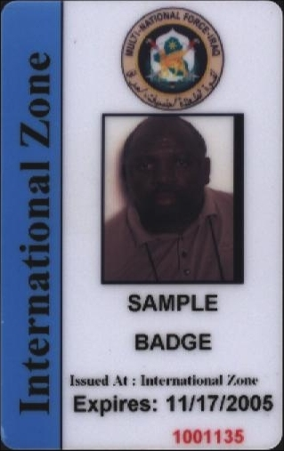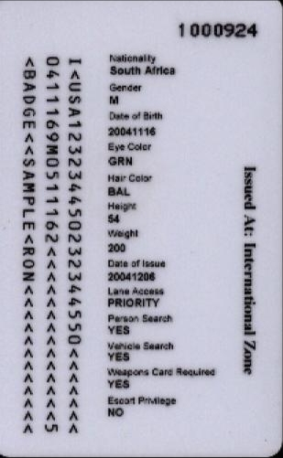
Badge color determined by category of person
Internal number used to track badges – printed on badge
FRONT
BACK
Indicates Installation in which access is authorized OR for Iraq-wide access
Installation which issued badge
Approximate location of hologram to aid in identification of potentially altered badges. Hologram is a half moon inside a sun, with a line underneath.
Internal number used to track badges – burned onto actual card; used to aid in identification of potentially altered badges.
Holes cut into the badge will cause damage
Chip – can be an aid in identification of potentially altered badges
Access controls for Issuing Installation
MNFI logo on back of badge can only be seen with UV light; used to aid in identification of potentially altered badges

Figure 1 - Overall Features
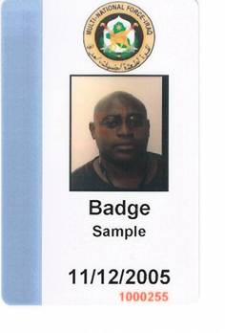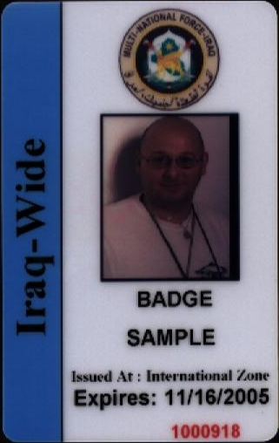
Earlier version, which is still valid.
Blank on colored stripe indicates “Iraq-wide” access.
Does not have the issuing organization (all of these were issued in the International Zone)
Does not have the word “Expires”
Badge restricted to a specific installation will have the name of the installation on the colored stripe. In this case, access is restricted to the International Zone
Badge authorizing access to all MNF-I installations have the words “Iraq-Wide” printed on the colored stripe (or blank, as shown to the right)

Figure 2 - Blue Badge

Figure 3 - Green 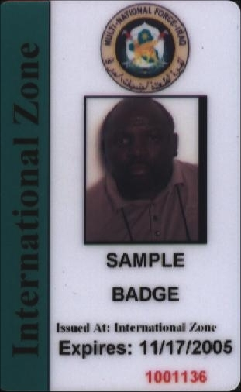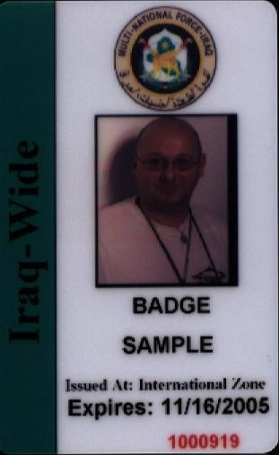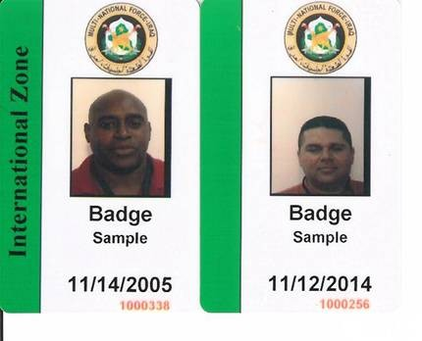
Earlier version, which is still valid.
Blank on colored stripe indicates “Iraq-wide” access.
Does not have the issuing organization (all of these were issued in the International Zone)
Does not have the word “Expires”
Badge restricted to a specific installation will have the name of the installation on the colored stripe. In this case, access is restricted to the International Zone
Badge authorizing access to all MNF-I installations have the words “Iraq-Wide” printed on the colored stripe (or blank, as shown to the right)

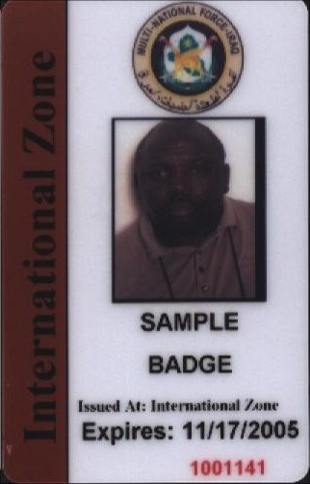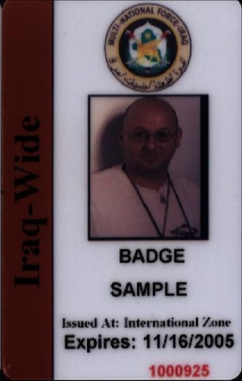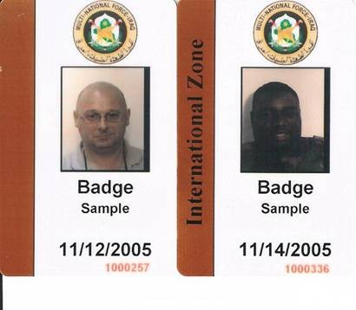
Earlier version, which is still valid.
Blank on colored stripe indicates “Iraq-wide” access.
Does not have the issuing organization (all of these were issued in the International Zone)
Does not have the word “Expires”
Badge restricted to a specific installation will have the name of the installation on the colored stripe. In this case, access is restricted to the International Zone
Badge authorizing access to all MNF-I installations have the words “Iraq-Wide” printed on the colored stripe (or blank, as shown to the right)

Figure 4 - Brown Badge

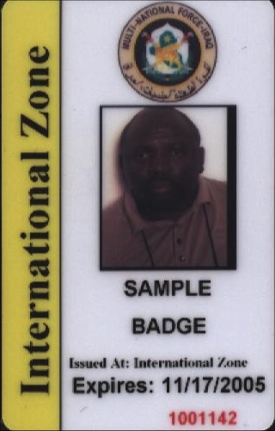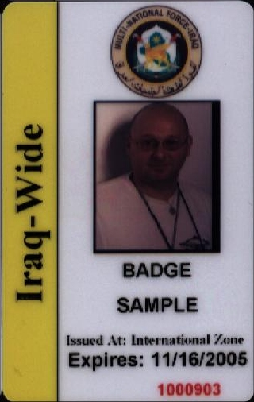
Badge restricted to a specific installation will have the name of the installation on the colored stripe. In this case, access is restricted to the International Zone
Badge authorizing access to all MNF-I installations have the words “Iraq-Wide” printed on the colored stripe (or blank, as shown to the right)

Figure 5 - Yellow Badge

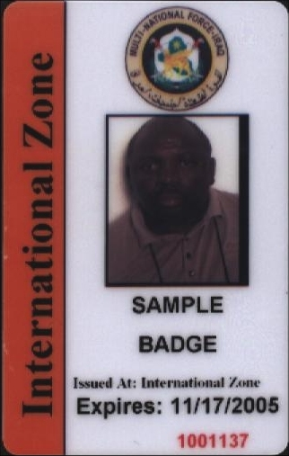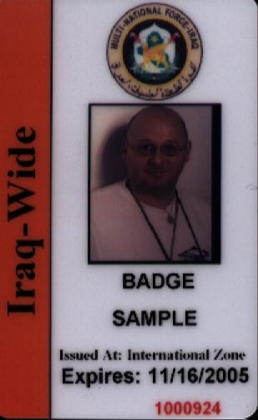
Badge restricted to a specific installation will have the name of the installation on the colored stripe. In this case, access is restricted to the International Zone
Badge authorizing access to all MNF-I installations have the words “Iraq-Wide” printed on the colored stripe (or blank, as shown to the right)

Figure 6 - Orange Badge
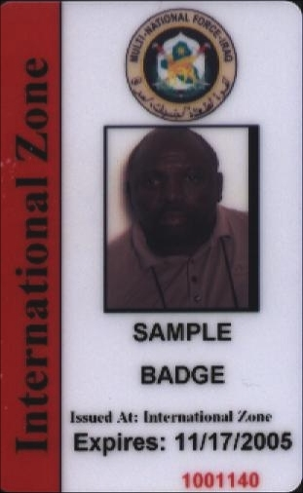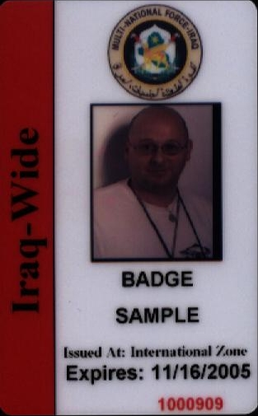
Badge restricted to a specific installation will have the name of the installation on the colored stripe. In this case, access is restricted to the International Zone
Badge authorizing access to all MNF-I installations have the words “Iraq-Wide” printed on the colored stripe (or blank, as shown to the right)

Figure 7 - Red Badge
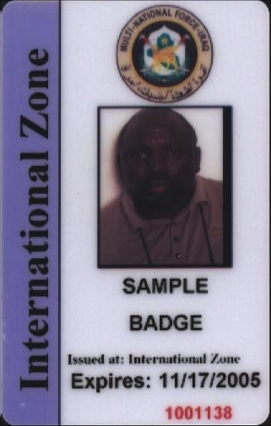
Purple is only issued to International Zone residents and employees. Access is not granted to any other installations.
Figure 8 - Purple Badge

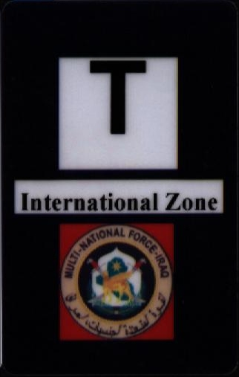
Temporary Visitor’s Badge issued at ECPs
Requires Escort
Badge is not allowed to leave the installation
Will not be accepted for “entrance” onto installations
Must be visibly displayed on individual at all times
Temporary
Installation Name

Figure 9 - Black Badge
Attachment J Badge Summary Sheet
Badge Type | Iraq  Wide (Y/N)
BLUE: (Coalition Partners and the highest level Iraqi officials)
MNFI Military | Y
Department of Defense Civilian Employees | Y
Other govt employees vetted thru national services (coalition partners) | Y
Coalition Embassy Nationals (Ambassadors, Staff, Employees) | Y
Noncoalition Embassy (Ambassadors Only) from NATO countries/UN Security Council Permanent Members | N
OGA (Other Govt Agencies) | Y
Top 5 IIG (Interim Iraqi Government) | Y
Top 5 IIG Immediate Families (parents, children and spouses residing in IZ) | N
Top 5 Iraqi military officers/civ equiv's | Y
IIG Ministers | N
UN SRSG | Y
GREEN: (Selected High level Iraqi officials (national/regional); selected UN, military, & non-coalition Embassy)
Key Non-coalition foreign embassy nationals (Ambassadors and Deputy Chief of Mission Only) | N
UN permanent international staff members (not local hires) | Y
Deputy Ministers | N
Iraqi National Council Members | N
Governors | N
Mayors | N
Commissioners | N
Regional, provincial, and city level council chairmen | N
City level police chiefs | N
Inspector Generals | N
Ministerial Director Generals | N
General grade officers (and civilian equivalents) of Iraqi Military, NG, and police | N
BROWN: (Coalition contractors - must provide CAC or equivalent)
Coalition non-host nation prime contractors | Y
Coalition non-host nation sub-contractors | Y
YELLOW: (Selected mid-level Iraqi officials; selected PSD, UN, military & non-coalition Embassy)
Deputy Governors | N
Deputy Mayors | N
Regional council members | N
Provincial council members | N
City level council members | N
Commissioned officers O1 to O6 (and civ equiv) of Iraqi military, NG, and police | N
PSD leaders | N
UN Local National/TCN staff leaders | N
Non-Coalition foreign Embassy nationals (Minister-Counselor, Counselor, | N
First Secretary, Second Secretary, Third Secretary, Attache', Military
Attache', Assistant Military Attache')
Media Personnel who work and live in the International Zone (also may be orange) | N
ORANGE: (Selected low-level Iraqi officials & employees; selected PSD, UN, military, & contractor leaders)
Ministerial General Managers and staff | N
Enlisted personnel in the grades of E1-E9 (and civ. Equiv) of the Iraqi military, | N
NG, and police
UN Local National/TCN staff members | N
Iraqi National Intelligence Service (INIS) | N
PSD members | N
Non-coalition contractor/subcontractor leaders
Locally hired TCN subcontractor leaders | N
Iraqi subcontractor leaders | N
Media Personnel who work and live in the International Zone (also may be yellow) | N
RED: (Non-coalition contractors & generally unvetted TCNs/Iraqi nationals)
Non-coalition contracted and subcontracted laborers | N
Locally hired TCN subcontracted laborers | N
Iraqi national laborers | N
Iraqi nationals who are employed within the International Zone | N

